 | 28 Editors - Preferences
Table of content
Detailed Table of content 2
Preferences 7
Navigation Sidebar 8
Interface Tab 8
Display Panel 9
Editors Panel 9
Translation Panel 10
Text Rendering Panel 12
Interface Font 12
Monospace Font 12
Menus Panel 12
Pie Menus 12
Themes 13
Presets 14
Install 14
Reset 14
List of Editors 14
Viewport 14
Display 15
Quality 16
Textures 16
Selection 17
Lights 17
Studio Lights 17
MatCaps 19
LookDevHDRI's 19
Editing 19
Objects 20
3D Cursor 20
Annotations 21
Weight Paint 21
Grease Pencil 22
Miscellaneous 23
Animation 23
Timeline 24
Addons 26
Header 26
Input 27
Keyboard 27
Mouse 27
Tablet 28
NDOF 28
Navigation 29
Orbit & Pan 29
Zoom 29
Fly & Walk 30
Key map 32
Header 32
Key map Editor 32
System 34
Cycles Render Devices 34
Memory and Limits 35
Sound 36
Save & Load 37
Blend Files 37
File Browser 39
File Paths 39
Data 39
Render 40
Applications 40
Development 41
Asset Libraries 41
Experimental 41

Detailed Table of content

Detailed table of content
Detailed Table of content 2
Preferences 7
Navigation Sidebar 8
Save Preferences menu 8
Auto Save preferences 8
Save current State 8
Revert to Saved 8
Load Factory Settings 8
Interface Tab 8
Display Panel 9
Resolution Scale 9
Line Width 9
Splash Screen 9
Tool tips 9
Python Tool tips 9
Developer Extras 9
Editors Panel 9
Region Overlap 10
Corner Splitting 10
Color Picker Type 10
Header Position 10
Factor Display Type 10
Translation Panel 10
Language 10
Tool tips 10
Interface 10
New Data 11
Text Rendering Panel 12
Anti Aliasing 12
Hinting 12
Interface Font 12
Monospace Font 12
Menus Panel 12
Open on Mouse Over 12
Top Level 12
Sub Level 12
Pie Menus 12
Animation Timeout 12
Top Key Timeout 13
Recenter Timeout 13
Radius 13
Threshold 13
Confirm Threshold 13
Themes 13
Presets 14
Create new Theme 14
Install 14
Reset 14
List of Editors 14
Viewport 14
Display 15
Object Info 15
View Name 15
Playback FPS 15
Gizmo Size 15
Object Origin Size 15
3D Viewport Axis 15
Off 15
Simple Axis 15
Size 15
Brightness 16
Interactive Navigation 16
Size 16
Quality 16
Viewport Anti-Aliasing 16
Multi sampling 16
Grease Pencil Multi sampling 16
Edit Mode Smooth Wires 16
Textures 16
Limit Size 16
Anisotropic Filtering 17
Clip Alpha 17
Image Display Method 17
Selection 17
Lights 17
Studio Lights 17
Install 18
Preview Window 18
Delete Studio Light 18
Copy Studio Light settings to the Studio Light Editor 18
Edit Studio Light 18
Save as Studio Light 18
Use Light 18
Diffuse 18
Specular 18
Smooth 18
Direction 18
MatCaps 19
LookDevHDRI's 19
Editing 19
Objects 20
New Objects 20
Link Materials To 20
ObData 20
Object 20
Align To 20
World 20
View 20
Enter Edit Mode 20
Instance Empty Size 20
Duplicate Data 20
3D Cursor 20
Cursor Surface Project 20
Cursor Lock Adjust 21
Annotations 21
Default Color 21
Eraser radius 21
Simplify Stroke 21
Weight Paint 21
Use Custom Colors 21
Tools Menu 21
Background Color 22
Gradient Stroke Mode 22
Grease Pencil 22
Manhattan Distance 22
Euclidean Distance 23
Miscellaneous 23
Sculpt Overlay Color 23
Node Auto Offset Margin 23
Animation 23
Timeline 24
Allow negative Frames 24
Minimum Grid Spacing 24
Time Code Style 24
Zoom To Frame Type 24
Keyframes 24
Visual Keying 24
Only Insert Needed 24
Auto Keyframing 24
Show Warning 25
Only Insert Available 25
Enable in new scenes 25
F-Curves 25
Unselected Opacity 25
Default Smoothing Mode 25
Default Interpolation 25
Default Handles 25
XYZ to RGB 25
Channel Group Colors 25
Addons 26
Header 26
Official / Community / Testing 26
Install Add-on 26
Refresh 26
Category 26
Search 26
List of Addons 27
Input 27
Keyboard 27
Emulate Numpad 27
Default to advanced numeric input 27
Mouse 27
Emulate 3 Button Mouse 27
Tablet 28
Tablet API 28
Max Threshold 28
Softness 28
NDOF 28
Pan Sensitivity 28
Orbit Sensitivity 28
Deadzone 28
Ndof View Navigate 28
Ndof View Rotation 28
Navigation 29
Orbit & Pan 29
Orbit Method 29
Orbit around selection 29
Auto Perspective 29
Auto Depth 29
Smooth View 29
Rotation Angle 29
Zoom 29
Zoom Method 30
Continue 30
Dolly 30
Scale 30
Zoom Axis 30
Invert Mouse Zoom Direction 30
Invert Wheel Zoom Direction 30
Zoom to Mouse Position 30
Fly & Walk 30
View Navigation 30
Walk 31
Reverse Mouse 31
Mouse Sensitivity 31
Teleport Duration 31
Walk Speed 31
Speed Factor 31
Gravity 31
View Height 31
Jump Height 31
Fly 31
Key map 32
Header 32
Key Configs 32
Import 32
Export 32
Filter Type 32
Search Field 32
Key map Editor 32
Map Type 33
Type of Event 33
Operator 33
Type of Event 33
Value 33
Secondary hotkeys 33
Specific settings 33
Restore 34
System 34
Cycles Render Devices 34
None 34
CUDA 34
OptiX 34
OpenCL 35
Memory and Limits 35
Undo Steps 35
Undo Memory Limit 35
Global Undo 35
Sequencer Cache Limit 35
Console Scrollback Lines 35
Use Disk Cache 35
Disk Cache Directory 35
Disk Cache Limit 35
Disk Cache Compression 35
Texture Time Out 35
Garbage Collection Rate 35
VBO Time Out 36
Garbage Collection Rate 36
Sound 36
Audio Device 36
OpenAL 36
OpenAL - OpenAL Soft 36
SDL 36
Null 36
Channels 36
Mixing Buffer 36
Sample Rate 37
Sample Format 37
Save & Load 37
Blend Files 37
Relative Paths 37
Compress File 37
Load UI 37
Save Preview Images 37
Tabs as Spaces 38
Save Prompt 38
Save Versions 38
Recent Files 38
Auto Save 38
Auto Save Temporary File 38
Timer 38
Auto Run Python Scripts 38
Excluded paths 38
File Browser 39
Filter File Extensions 39
Hide Dot File/Data-blocks 39
Hide Recent Locations 39
Hide System Bookmarks 39
Show Thumbnails 39
File Paths 39
Data 39
Fonts 39
Textures 39
Scripts 39
Sounds 40
Temporary Files 40
Render 40
Render Output 40
Render Cache 40
Applications 40
Image Editor 40
Animation Player 40
Development 41
I18n Branches 41
Asset Libraries 41
Experimental 41

Preferences
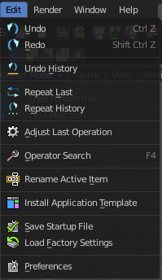
The Preferences is the place where you can tweak several settings to your needs. It can be opened in the Edit menu in the top bar.

The Preferences contains several tabs. And every tab contains several rows or panels with content. We will go through them one by one.

When you have changed something, and want that changes to be permanent, then you are required to save the user settings. See the Save User Settings button in the header.

Navigation Sidebar
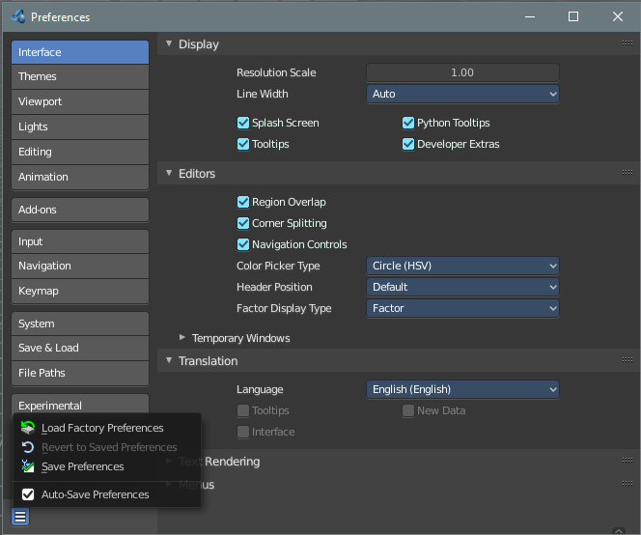
At the left side you will find the navigation elements to access the different categories. At the bottom resides the Save Preferences menu.

Save Preferences menu

Auto Save preferences
Changes at the preferences are saved automatically when Auto Save Preferences is ticked. When this option is off, then changes needs to be saved manually. When you don't save the changes, then Bforartists loads the next time with the status before the changes.

Save current State
Manually saves the current state.

Revert to Saved
This option is just available when Auto Save preferences is off. It reverts the settings to the last saved state.

Load Factory Settings
Resets the settings to the factory defaults.
Note
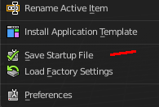
Not everything can be changed from the Preferences. Everything regarding layout is stored in the Startup File, and not in the Preferences. So when you want to save a layout change then you have to save the startup file. The menu item is right above the Preferences button in the Edit menu.

Interface Tab
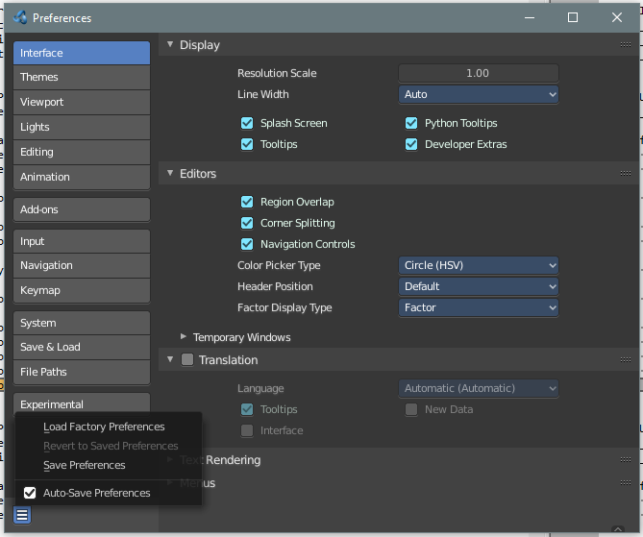
The Interface category contains settings to change how UI elements are displayed and how they react.

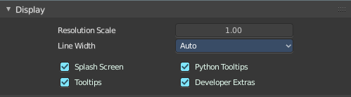
Display Panel

Resolution Scale
At 4K displays the whole UI elements are usually ways too small. Scale the whole UI size display by moving the slider to the needed value.

Line Width
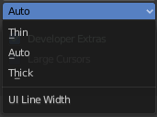
Define the size of the line between the editors. This is a theming setting.

Splash Screen
Display the Splash Screen when starting Bforartists.

Tool tips
Display tool tips in the UI. With this feature unticked you won't see any tool tips anymore. It is not recommended to turn this feature off. The icon buttons needs the tool tips to display the tool name.

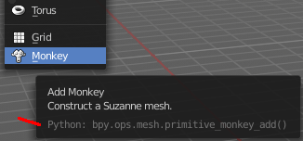
Python Tool tips
Every tool tip can also display the Python code tag for the tool. It may look like noise in the first moment. But can give you some further hints here and there. Some tool tips, like the Node editor buttons, doesn't have a proper tool description by design. Here the Python tool tip can tell you the function when you turn it into pure icon buttons.
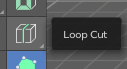
The tools in the tool shelf doesn't have a Python tool tip by design. This buttons sits on top of the normal operators, and doesn't access the tool tip of it.
Note: It is not recommended to turn the Python tool tips off.

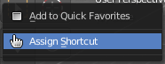
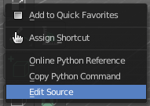
Developer Extras
This tick box turns on or off the developer entries in the right click menus.

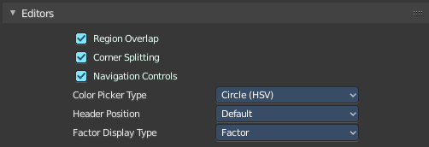
Editors Panel

Region Overlap
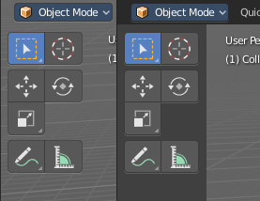
This checkbox will enable Blender to draw the Header, Tool Shelf and the Sidebar overlapping the 3D View. The transparent areas becomes workspace area. You can for example select vertices now in the transparent areas.
If you have a capable graphics card and drivers with Triple Buffer support, clicking the checkbox will enable the overlapping regions to be drawn using the Triple Buffer method, which will also enable them to be drawn using Alpha, showing the 3D View contents trough the Object Tools and Transform Properties regions.

Corner Splitting
This feature enables you to split editors by dragging the upper right or lower left corner around.

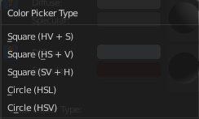
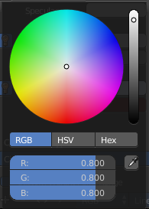
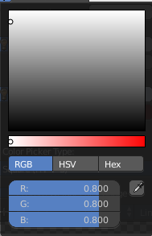
Color Picker Type
Choose the type of Color picker that will show when you click on a color field. You can choose between three square types and two circle types.

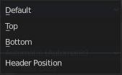
Header Position
Define at which default position the headers of the editors should reside.

Factor Display Type
Display factor values either as percentage or as factor.

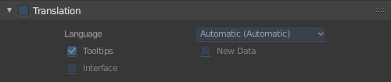
Translation Panel
Choose another default language for Bforartists.

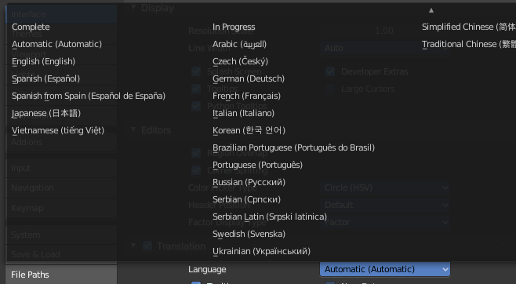
Language
Choose between automatic language detection. In this case the system language gets chosen. Or pick a language that you want to use.

Tool tips
Tool tips translates the tool tips too.

Interface
Interface translates all the interface texts

New Data
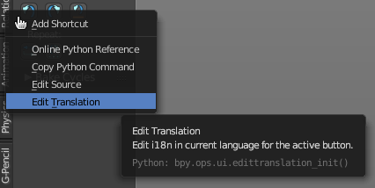
New data is meant to edit the localization texts.
This can be done in the right click menus of the tools when everything is set up in the correct way.
This is a development feature. You need a repository of Bforartists!

Note
This feature is currently not functional in Bforartists. It ends in an error message.

Let's nevertheless document the way how it should work. Note that you need a Bforartists repository for that. The binary version does not come with the editable *.po files, but with already compiled *.mo files for the translation.
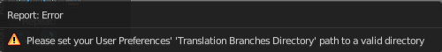
Note that you first need to set the path to the translation files for that. Or you will get an error. This is done in the File tab. The |18n string.
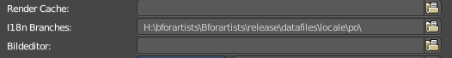
The path should lead to the *.po files that you want to translate. Which can be found in the Bforartists repository.

And you need to enable the Manage UI translations add-on. And to fix the paths in this add-on. The default paths are currently set for Blender.

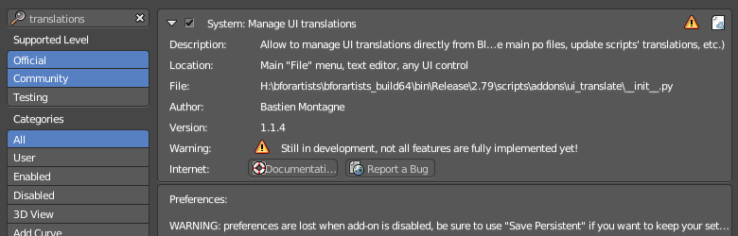

And then you might end in this error here ...
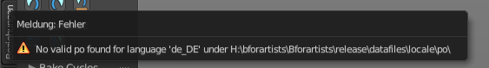

In case somebody has an idea what's going on here, every hint is welcome ...

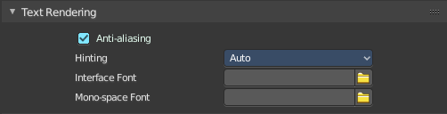
Text Rendering Panel
Text related settings for the font of the interface.

Anti Aliasing
Use Anti Alias at the UI elements to prevent pixelated look of the font.

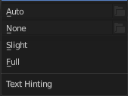
Hinting
What sharpening method to use to make the text render sharp.

Interface Font
Define a custom interface font. The font in the whole UI.

Monospace Font
Define a custom Monospace font. That's the one used in the python console for example.

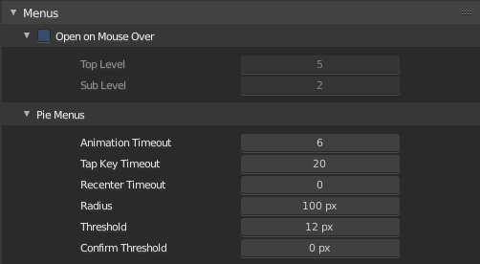
Menus Panel

Open on Mouse Over
Normally you click at a menu to open it. With Open on Mouse Over the menu opens up when you just hover with the mouse over it.

Top Level
Adjust the time delay before the top level menu opens on mouse over.

Sub Level
Adjust the time delay before a sub level menu opens on mouse over.

Pie Menus
Bforartists has some pie menus that can be called by hotkeys. Here you find some settings for it.

Animation Timeout
The pie menu fades in with an animation. Adjust the time needed to fully unfold the pie menu.

Top Key Timeout
Pie menu button longer held than this time will dismiss the menu on release.

Recenter Timeout
Pie menus will use the initial mouse position as center for this amount of time. The value is in 1/100 seconds.

Radius
The pie menu size in pixels.

Threshold
The distance that is needed from the center to move the mouse so that a selection can be made.

Confirm Threshold
Distance threshold after which selection is made. A value of zero disables this feature.

Themes

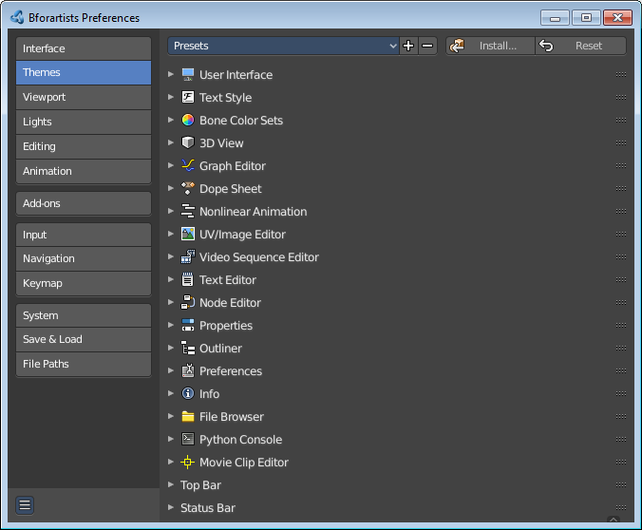
The Themes tab allows you to customize interface appearance and colors. There are various elements that can be themed.
Any change here will appear in real-time on your screen in the corresponding editor.
To change a color for a UI element, simply click at one of the color fields. A color dialog will open up to choose a new color.
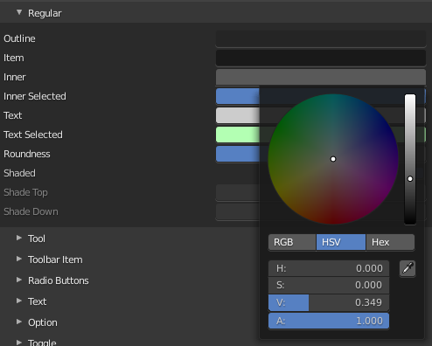

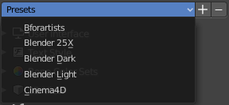
Presets
Bforartists comes with several theme presets. You can choose between them in the drop down box. Don't forget to save the user settings to make the change to the new preset permanent.

Create new Theme
To create a new theme, click the + button next to the preset selection drop-down and enter a name. This will save the theme to an XML file in the ./scripts/presets/interface_theme/ sub directory of one of the configuration directories.
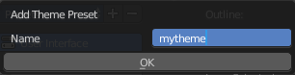
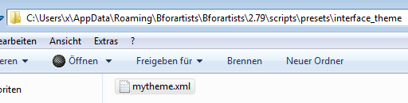
To share the new created theme you have to copy it from that folder. This XML file can then be loaded as a theme at another computer with Bforartists installed.

Install
Install an external theme. This button will open a file browser.

Reset
Resets all made changes, and resets the current theme to its initial state.

List of Editors
The list of the editors that you can theme. Every editor can have its own theming.

Viewport

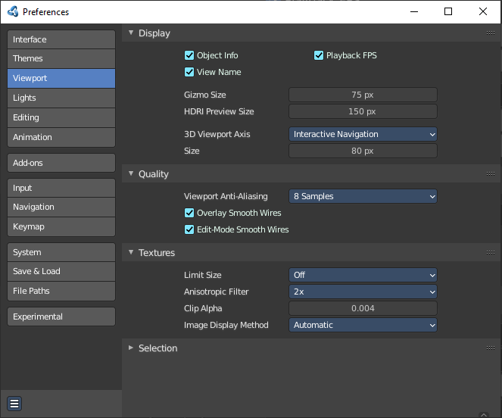
Contains the settings for the 3D Viewport.

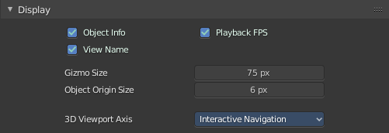
Display

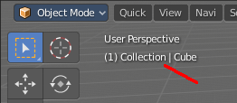
Object Info
Display current frame, collection name and Object name in the upper left edge of the 3D view.
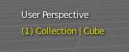
The letters appears in yellow when the current frame of the selected object has a keyframe.

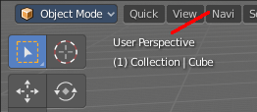
View Name
Display the name of the current view up left in the 3D view.

Playback FPS
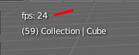
Show the frames per second screen refresh rate while an animation is played back. It appears in the viewport corner, displaying red if the frame rate set cannot be reached. And replaces the View name while the animation is playing.

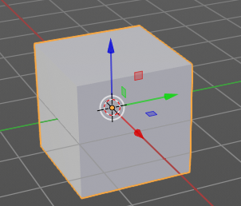
Gizmo Size
Adjust the size of the transform gizmo that appears when you have one of the transform tools activated.

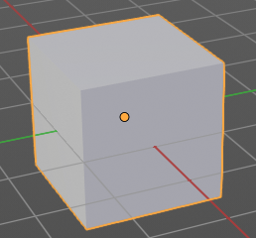
Object Origin Size
Adjust the size of the orange dot that represents the center of the object. The pivot.

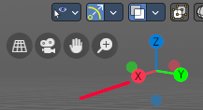
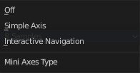
3D Viewport Axis
Adjust the apperance of the 3D Viewport mini axis widget.

Off
Hides the Mini axis widget

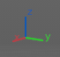
Simple Axis
Shows simple axis. This widget type is not interactive. It just shows the state of the viewport rotation.

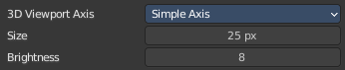
Size
The size of the simple mini axis widget.

Brightness
The brighness of th simple mini axis widget.

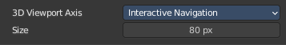
Interactive Navigation
The default mini axis widget. This widget is interactive. Clicking and dragging will rotate the viewport. Clicking at one of the colored spots at the end of the axis will snap to the neares orthographic view.

Size
The size of the interactive navigation widget.

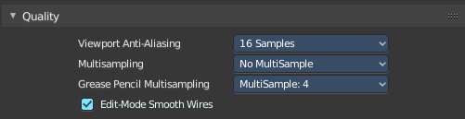
Quality
Contains the settings to adjust the display quality in the viewport.

Viewport Anti-Aliasing
The anti alias quality settings for the solid mode rendering in the 3d viewport.

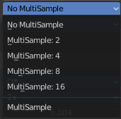
Multi sampling
Set the OpenGL Multi sampling in case your system supports it.

Grease Pencil Multi sampling
The grease pencil drawing has its own OpenGL Multi sampling. Set the OpenGL Multi sampling in case your system supports it.

Edit Mode Smooth Wires
Enable Edit Mode edge smoothing which reduces anti alias and makes the edge more sharp. A change requires a restart of the software.

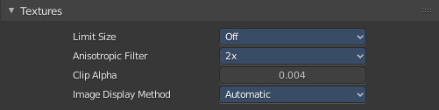
Textures

Limit Size
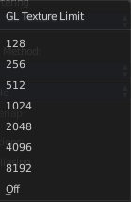
Limit the maximum resolution for pictures used in textured display to save memory. The limit options are specified in a square of pixels, (e.g.: the option 256 means a texture of 256×256 pixels) This is useful for game engineers, whereas the texture limit matches paging blocks of the textures in the target graphic card memory. Available Options are: Off (No limit), 128, 256, 512, 1024, 2048, 4096, and 8192.

Anisotropic Filtering
Sets the level of anisotropic filtering. This improves the quality of how textures are drawn at the cost of performance. Available Options are: Off (No Filtering), 2x, 4x, 8x, and 16x.

Clip Alpha
Clip alpha when the value is below the here defined value.

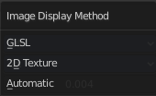
Image Display Method
The method that is used to draw textures in the viewport.

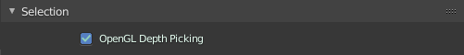
Selection
OpenGL Depth picking tries to pick the object in front. Without this method you may pick an object underneath.

Lights
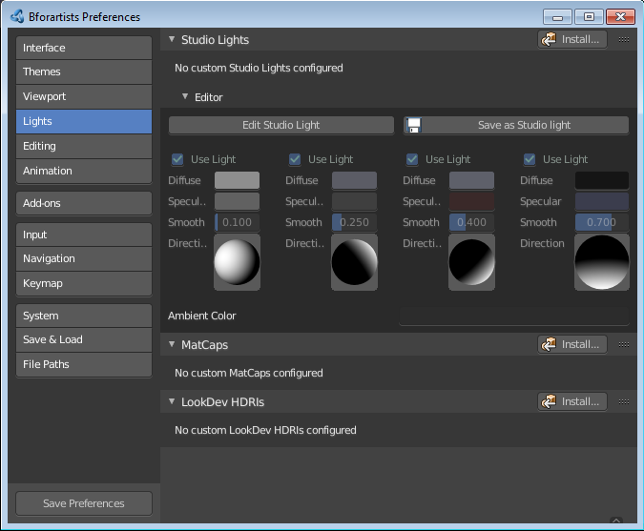
The viewport uses different light setups in different situations. You can switch between them in the shading drop down in the 3d view up right.

This tab allows you to customize these light setups. And install custom light setups.

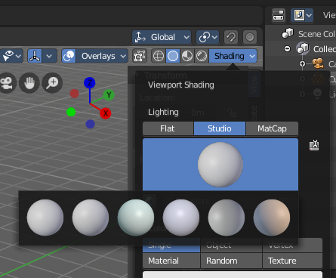
Studio Lights
The 3D view uses Solid OpenGL lamps to light the 3D view. You can enable four different light sources here. These lamps does not affect the rendering. Their only purpose is to light the 3D view.
You can turn on or off the lamps. But there should be at least one light enabled.

Install
Install an external studio light.

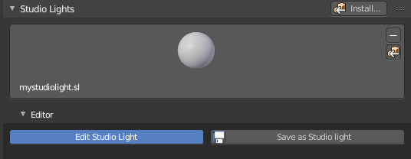
Preview Window
This window appears when you have a studio light saved, or a new studio light installed.
Down left you can see the name of the saved library. mystudio.sl .
This window gives you a preview of how this studio light looks like in the 3D view then.
Up right you can find two buttons.

Delete Studio Light
Deletes the studio light.

Copy Studio Light settings to the Studio Light Editor
The editor settings does not update immediately. It shows the default studio light setting. So when you want to edit the studio light, then you want to press this button to update the editor values first.

Edit Studio Light
Enable the editing of the studio light setup.

Save as Studio Light
Save the current light setup as a studio light setup. Note that this does not export the light, but saves its settings internally in the appdata directory.

Use Light
Turn on or off this specific light.

Diffuse
Diffuse color is the constant color of the lamp.

Specular
Specular is the highlight color of the lamp.

Smooth
Smooth the lighting from this specific light.

Direction
Adjust the direction. Click into the field and drag the sphere around until you have your desired light setup.

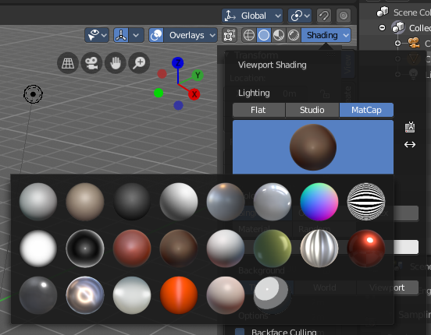
MatCaps
Matcaps is a special material that can be assigned quickly to preview geometry. Usually matcaps are used while sculpting. You can switch between them in the shading drop down in the 3d view up right.
Install and manage custom matcaps.

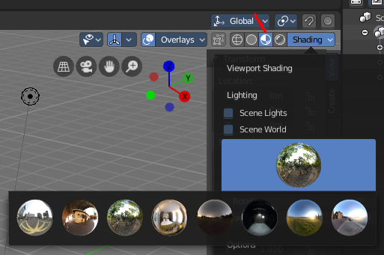
LookDevHDRI's
You can light the scene with an environment image instead of lights. This is done with hdri images.
The viewport can do this in realtime when the shading is set to Viewport Shading.
Install and manage custom LookDev HDRI's. Basically every image could do the trick here. But the hdri's uses a special spherical mapping. So you better use hdri images for this purpose.
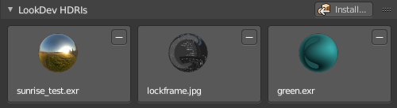

Editing

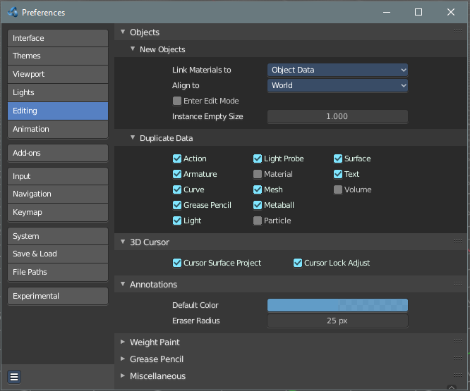
Contains the settings around editing. Objects, Data, etc.

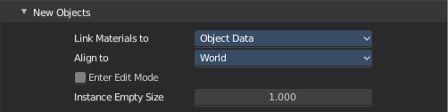
Objects

New Objects

Link Materials To
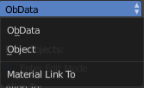
Define how materials will be linked to its objects. Almost everything in Bforartists is organized in a hierarchy of data-blocks. A data-block can be thought of as containers for certain pieces of information. For example, the Object data-block contains information about the Object’s location while the Object Data ObData data-block contains information about the mesh.

ObData
Any created material will be created as part of the ObData data-block.

Object
Any created material will be created as part of the Object data-block.

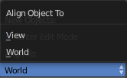
Align To

World
New objects align with world coordinates.

View
New object align with view coordinates.

Enter Edit Mode
If selected, Edit Mode is automatically activated when you create a new object.

Instance Empty Size
Increase or decrease the size of collection empties.

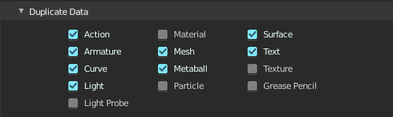
Duplicate Data
When you duplicate data, then most or all its subpart gets duplicated too. Define which supports should be duplicated when you duplicate an object.

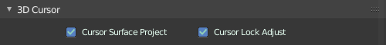
3D Cursor

Cursor Surface Project
Use the surface depth to place the 3D cursor. That way you can place the 3D cursor at the surface of an object.

Cursor Lock Adjust
Place the cursor without a jumping effect at the new location when lock to cursor is used.

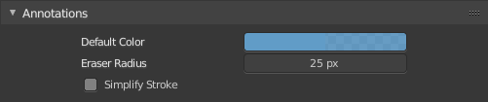
Annotations

Default Color
The default color for the annotations pencil.

Eraser radius
The eraser radius.

Simplify Stroke
Simplify the final stroke.

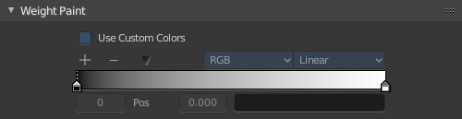
Weight Paint

Use Custom Colors
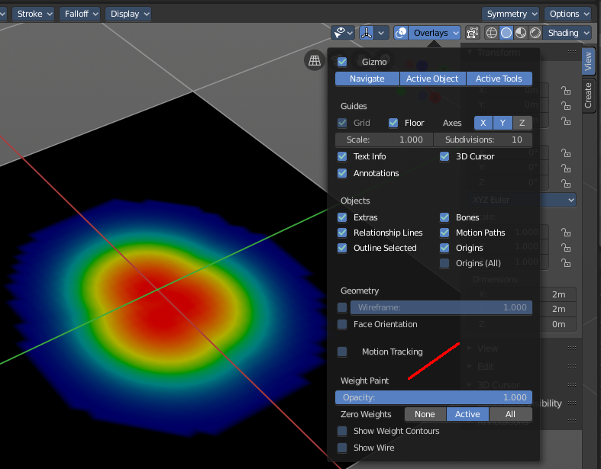
Bforartists uses by default a gradient that goes from red to green to blue to black to display the different weight at a mesh.
Setup a custom gradient for the colors of a weight paint.

The + Button adds a color stop point, which can be moved around. That way you can have more than one color in the gradient.

The - Button removes the currently selected color stop point.


Tools Menu
Flip Color ramp flips the color ramp.
Distribute Stops from Left distributes the color stops from the left. The position at the right will remain empty.
Distribute Stops evenly distributes the color stops evenly across the gradient.
Eyedropper allows you to pick a color from the gradient.
Reset color ramp resets the color ramp to the default state.

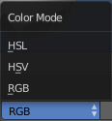
Color Mode is a drop down box to choose the color mode for the gradient.

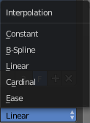
Interpolation is a drop down box to choose the interpolation mode for the gradient.

In the Color Ramp element you will see the color ramp with the single color stops.
Choose Active Color Stop is the stop point of the gradient.
Position is an edit box where you can numerically fine tune the position of the currently selected color stop.
Color Ramp Element displays the color of the current selected color stop. When you click at it then you can open a color picker to change the color of the current color stop.

Background Color
Background color is the same color than the secondary color from the color picker. When you click at it then you can open a color picker to change the secondary color.

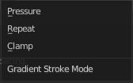
Gradient Stroke Mode
Set the gradient stroke mode.

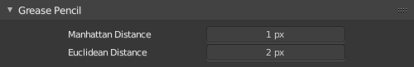
Grease Pencil

Manhattan Distance
The minimum number of pixels the mouse has to move horizontally or vertically before the movement is recorded.

Euclidean Distance
The minimum distance that mouse has to travel before movement is recorded.

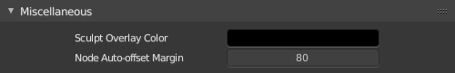
Miscellaneous

Sculpt Overlay Color
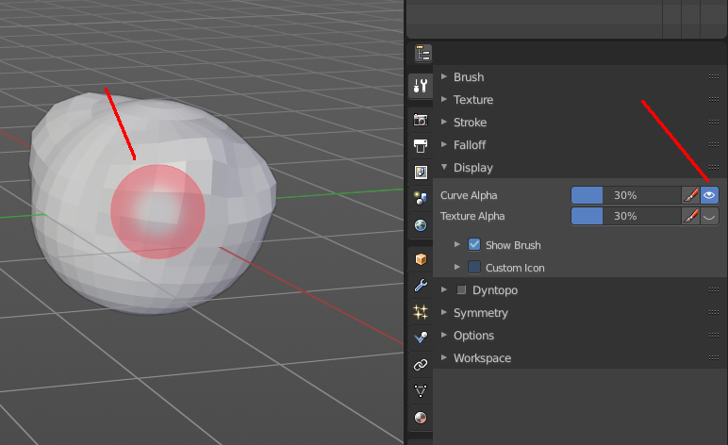
This color button allows the user to define a color to be used in the inner part of the brushes circle when in sculpt mode, and it is placed as an overlay to the brush, representing the focal point of the brush influence.
The overlay color is visible only when the overlay visibility is selected (clicking at the eye to set its visibility), and the transparency of the overlay is controlled by the alpha slider located at the brush pop-up, located at the top of the tool shelf, when in sculpt mode.

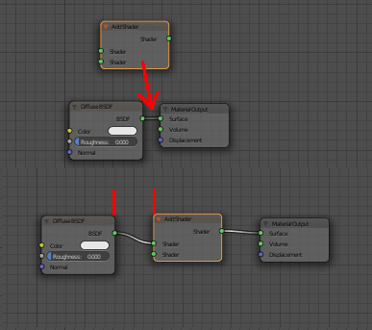
Node Auto Offset Margin
Minimum distance in the node editor between nodes for auto offsetting.
When you insert a new node between two existing connected nodes, then the two nodes gets pushed to left and right, with an offset. Adjust this offset.

Animation

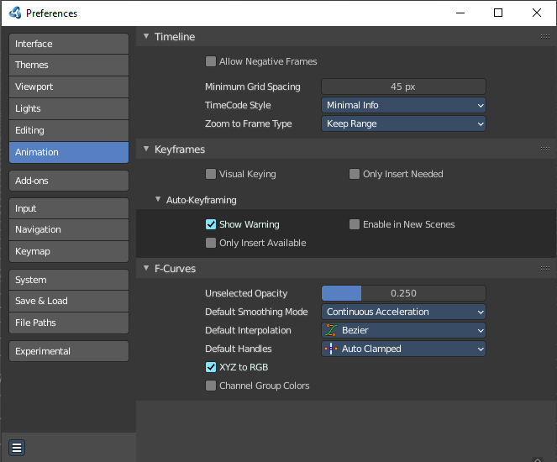
Contains the settings for the animation editors.

Timeline

Allow negative Frames

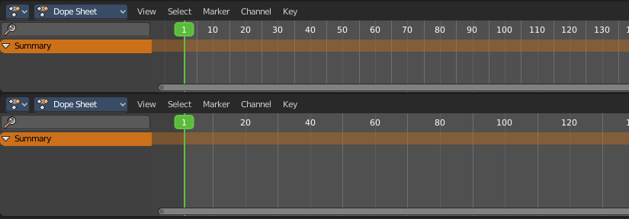
Minimum Grid Spacing
Adjust the minimum number of pixels between grid lines in a 2D viewport. This affects for example Timeline, Dope sheet, Graph or NLE Editor.

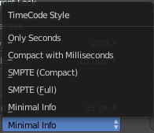
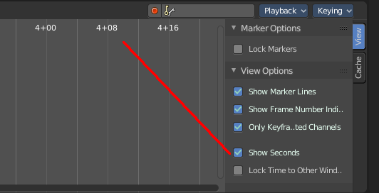
Time Code Style
In Timeline, Dope sheet, Graph and NLE editor you can either display the keyframe number or the time in the timeline. Define how the time gets displayed when you have chosen to display time.

Zoom To Frame Type
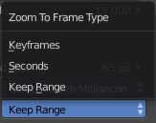
Timeline, Dope sheet, Graph and NLE. Define how zooming to frame focuses around current frame.

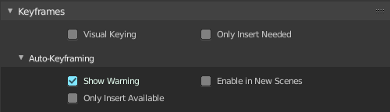
Keyframes

Visual Keying
When an object is using constraints, the objects property value doesn't actually change. Visual Keying will add keyframes to the object property, with a value based on the visual transformation from the constraint.

Only Insert Needed
This will only insert keyframes if the value of the property is different.

Auto Keyframing

Show Warning
Displays a warning at the top right of the 3D View, when moving objects, if Auto Keyframe is on.

Only Insert Available
This will only add keyframes to channel F-Curves that already exist.

Enable in new scenes
Automatic keyframe insertion for objects and bones as Default setting for new scenes.

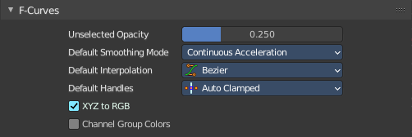
F-Curves

Unselected Opacity
The amount that unselected F-curves stands out from the background in the Graph Editor.

Default Smoothing Mode
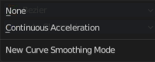
Auto handle smoothing mode for new added curves. None or Continuous accelleration.

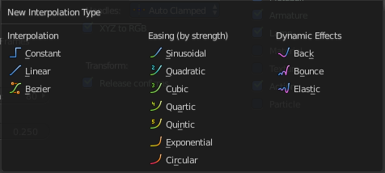
Default Interpolation
This controls how the state between two keyframes is computed. Default interpolation for new keyframes is Bezier which provides smooth acceleration and de-acceleration whereas Linear or Constant is more abrupt.

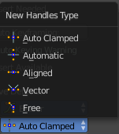
Default Handles
The default handle types for F-Curves.

XYZ to RGB
Color for X, Y or Z animation curves (location, scale or rotation) are the same as the color for the X, Y and Z axis.

Channel Group Colors
Use animation channel group colors. Uses the bone group colors.

Addons

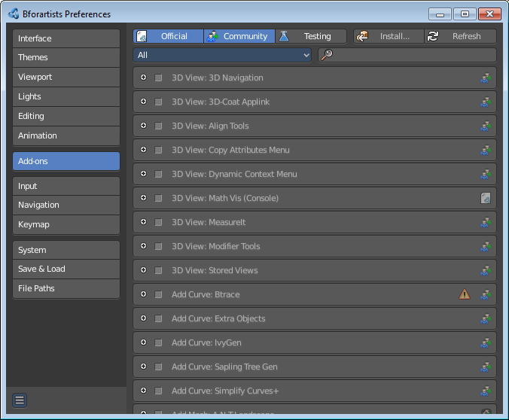
An add-on is external software written by other developers. Add-ons are a way to extend the core functionality of Bforartists. Bforartists already comes with lots of add-ons. Some already activated. Here you can manage them, and add even more add-ons if required.
Note that Bforartists works with Blender addons.

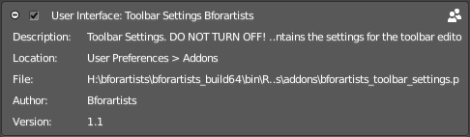
Note also that this list contains some add-ons that are required by Bforartists to work proper. You will see a warning in those addons. Don't turn them off. Or vital parts of Bforartists will not longer work. Like the toolbar.

Header

Official / Community / Testing
Filter the addons by supported level.
The addons comes in three flavors. The official addons are the addons from the Blender developers. Community are the addons from Community developers that doesn't officially belong to the Blender developer team. And Testing add-ons are add-ons that aren't really finished yet. They can do the job, but are experimental.

Install Add-on
Install external add-ons. Note that addons that comes as a zip file should be loaded zipped. And not unzipped.

Refresh
Scan the add-on directories for new modules. This is useful when you decide to install an add-on manually.

Category
Refine the search down to single categories.

Search
Search for keywords.

List of Addons
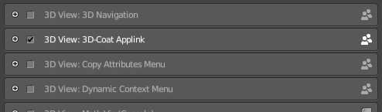
This is the list of installed add-ons. Installed does not necessarily mean that they are enabled. To enable an add-on, tick the checkbox at the left. When you expand an add-on then you will find some further informations. Sometimes you will also find some more settings.

Input
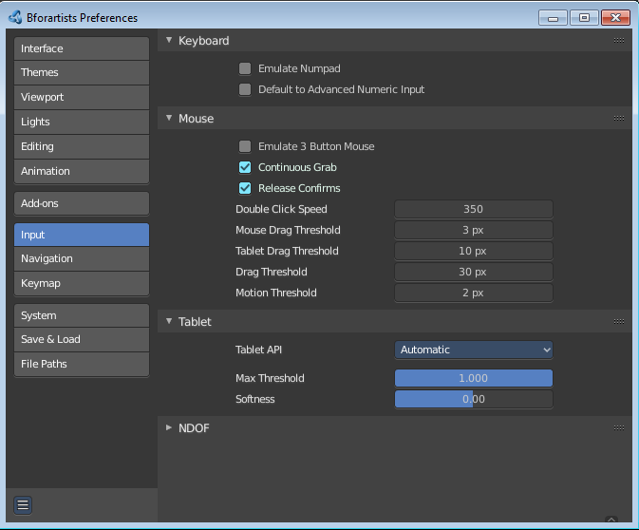

This tab contains some input related settings.

Keyboard

Emulate Numpad
Laptops usually doesn't have Numpad keys. Choose to use the number keys above the letters as Numpad keys.

Default to advanced numeric input
When entering numbers while transforming default to advanced mode for full math expression evaluation.

Mouse

Emulate 3 Button Mouse
In the Windows world 3 button mouses are common. But Apple for example has a single mouse button. Bforartists can emulate a 3 button mouse. The third mouse button will then be emulated by a key combination.
3-button Mouse | 2-button Mouse | Apple Mouse
LMB | LMB | LMB (mouse button)
MMB | Alt-LMB | Alt-LMB (Option/Alt key + mouse button)
RMB | RMB | Cmd-LMB (Command/Apple key + mouse button)

Mouse/Keyboard combinations referenced in this manual can be expressed with the combinations shown in the table. For example, MMB drag becomes Alt-LMB drag. Shift-Alt-RMB becomes Shift-Alt-Cmd-LMB on a single-button mouse.

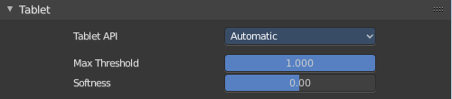
Tablet
This panel contains some tablet related settings.

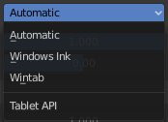
Tablet API
Choose which API Bforartists should choose for the pressure sensitivity of your tablet.

Max Threshold
The raw input pressure value which is interpreted as 100 % by Bforartists.

Softness
Adjust the pressure softness of the low pressure response onset using a gamma curve.

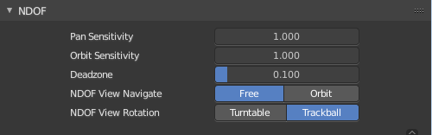
NDOF
You can use a 3D mouse in Bforartists. Here you find some 3D mouse related settings.

Pan Sensitivity
Adjust the pan sensitivity.

Orbit Sensitivity
Adjust the orbit sensitivity

Deadzone
The initial movement that is needed before the movement gets recognized.

Ndof View Navigate
Choose the navigation style between Free and Orbit.

Ndof View Rotation
Adjust in what style you rotate the 3D View. Turntable and Trackball navigation reacts a bit different. Turntable navigation tries to hold the horizon line while rotation. Turntable rotation rotates also the horizon line.

Navigation
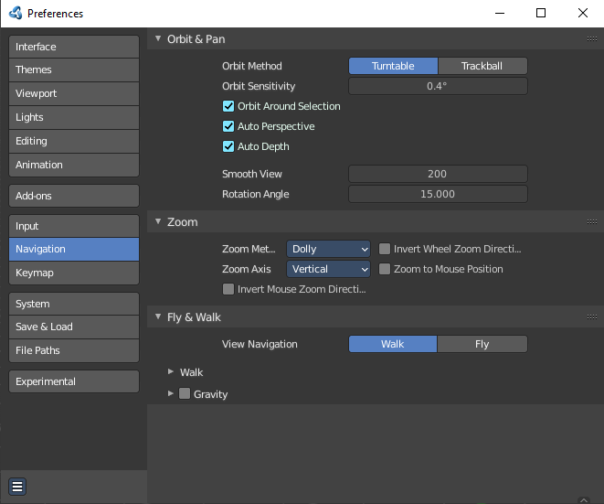
The navigation section contains the settings for navigating in the 3D view.

Orbit & Pan

Orbit Method
Adjust in what style you rotate the 3D View. Turntable and Trackball navigation reacts a bit different. Turntable navigation tries to hold the horizon line while rotation. Turntable rotation rotates also the horizon line.

Orbit around selection
The selected object becomes the rotation center of the viewport. When there is no selection the point of the last selection will be used.

Auto Perspective
With Auto perspective off when you switch to one of the side views, then the chosen orthographic or perspectivic view is kept. Means when you have the distorted perspectivic view, and switch to top view, then your mesh will be perspectivic distorted here too.
With Auto Perspective the view in the side views will be orthographic, and not perspectivic, no matter what View Persp/Ortho is chosen.

Auto Depth
Use the depth under the mouse to improve view pan, rotate, zoom functionality.

Smooth View
The switch to change to another view is animated. Adjust the length of time the animation takes when changing the view with the Numpad (Top/Side/Front/Camera...). A value of zero will remove the animation, and immediately switch to the chosen view.

Rotation Angle
Rotation step size in degrees, when Numpad4, Numpad6, Numpad8, or Numpad2 are used to rotate the 3D View.

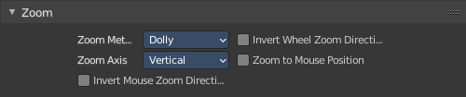
Zoom

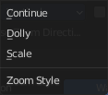
Zoom Method
Adjust the zoom style.

Continue
The Continue zooming option allows you to control the speed (and not the value) of zooming by moving away from the initial click point. Moving up from the initial click-point or to the right will zoom out, moving down or to the left will zoom in. The further away you move, the faster the zoom movement will be.

Dolly
Dolly zooming works similarly to Continue zooming except that zoom speed is constant.

Scale
Scale zooming depends on where you first click in the view.

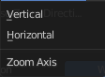
Zoom Axis
With Vertical moving up zooms out and moving down zooms in. With Horizontal moving left zooms in and moving right zooms out.

Invert Mouse Zoom Direction
Inverts the Zoom direction for Dolly and Continue zooming.

Invert Wheel Zoom Direction
Inverts the direction of the mouse wheel zoom.

Zoom to Mouse Position
When enabled, the mouse pointer position becomes the focus point of zooming instead of the 2D window center.

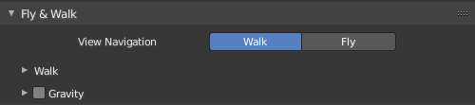
Fly & Walk
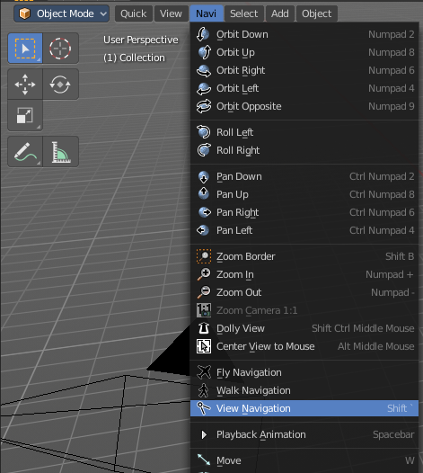
Fly and walk are special navigation modes. They can be found in the Navi menu. The Fly & walk section also contains some settings from the View navigation style, since this style uses elements from walk and fly navigation too.

View Navigation
Adjust how the View navigation in the 3D view behaves. You can choose between walk and fly.

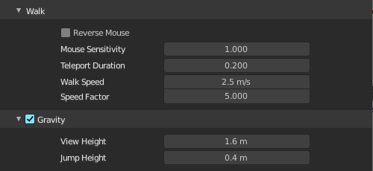
Walk

Reverse Mouse
Reverse the mouse movement when you move upwards or downwards

Mouse Sensitivity
Adjust how strong the viewport movement reacts to the mouse movement

Teleport Duration
Adjust the teleport duration when teleporting in navigation mode.

Walk Speed
Adjust the walk speed

Speed Factor
Adjust the run speed.

Gravity
Choose if the virtual character, your point of view, uses gravity.

View Height
Adjust the height of the point of view for your virtual character. This setting requires to have Gravity on.

Jump Height
Adjust the maximal jump height for your virtual character. This setting requires to have Gravity on.

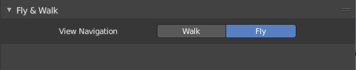
Fly
Fly has no further settings.

Key map
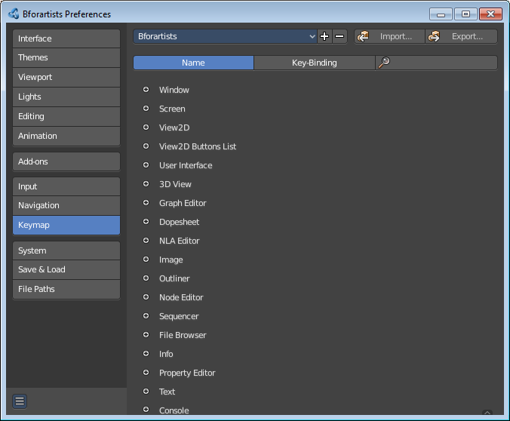
The key map allows you to customize how Bforartists reacts to mouse and keyboard, and change key map entries. All Input behavior is defined in the key map.

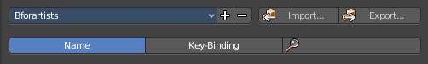
Header

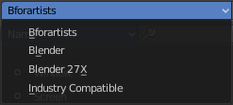
Key Configs
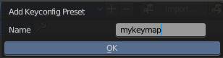
A drop down menu to choose existing key maps. The + button at the right adds a new key map. The current configuration will then be saved as a new key map.

Import
Import an external key map. This opens up a file selector to choose the python file.

Export
Export a key configuration python file from Bforartists.

Filter Type
Define if you want to search for a tool name or for a hotkey. By tool name, or by the hotkey name

Search Field
Enter a search string.

Key map Editor
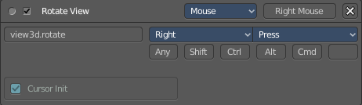
The Key map editor is the list where the single inputs are defined. Every input can have several specific operator settings in the lower area. The upper area defines the general things like the key combos. The lower area those operator specific settings.

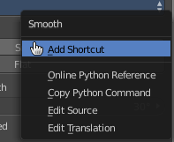
Normally you don't edit those key entries manually. Most of the usual tools have an entry in the right click menu to create or to change the hotkey. But sometimes you have to do this task manually.

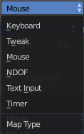
Map Type
Here you define what input will control the function.

Type of Event
Here you define your main hotkey. In our case the right mouse.

Operator
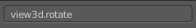
The Python operator name for the tool.

Type of Event
The main hotkey again. For special events like mouse events you have a drop down box here.

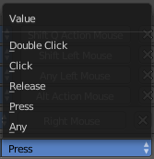
Value
What key action is required. On click, on double click, etc. ...

Secondary hotkeys
Many hotkeys uses a key combination, for example Shift D for select. Define those secondary hotkeys.

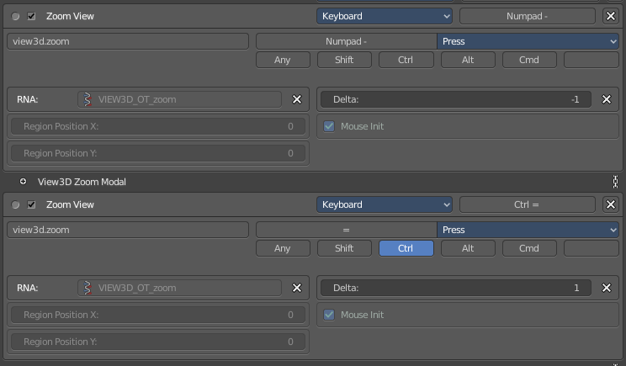
Specific settings
Every operator can have several settings. And some tools even just defines itself by those different settings. Here you can see two different zoom view operators. They just differ in the Delta value.
What is equal in the key map in all cases is the RNA entry. That's the name of the operator again. But this time not the Python code operator name. But the C code operator name.

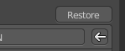
Restore
When you modify a key map item, then you will see a Restore button appear at the right side. This indicates that this key map item got modified. A click at the Restore button will restore the original hotkey.

System

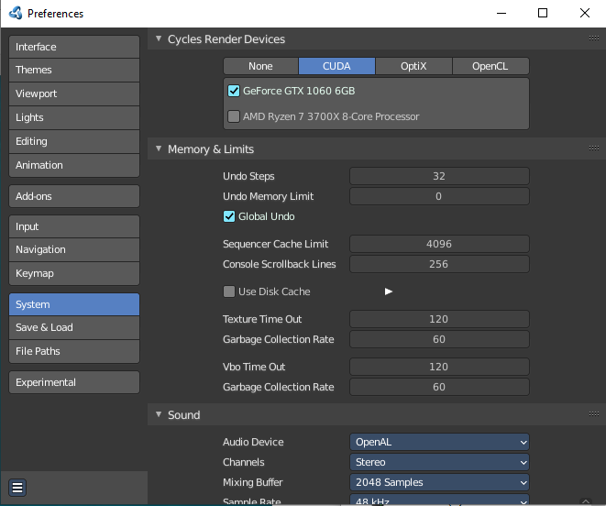
The system tab contains system relevant settings. Such as Cuda for Cycles renderer or OpenCL or Memory related settings.

Cycles Render Devices
The Options here will set the compute device used by the Cycles render engine.

None
When set to None or the only option is None: your CPU will be used as a computing device for Cycles Render Engine.

CUDA
If the system has a compatible Nvidia CUDA enabled graphics card you will be able to use it to render with the Cycles render engine.

OptiX
Optix is a raytracing framework from Nvidia that runs on the GPU.

OpenCL
If the system has a compatible OpenCL device, it will show up has an option for rendering cycles.

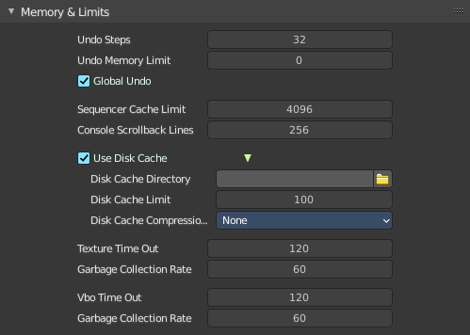
Memory and Limits

Undo Steps
Number of Undo steps available.

Undo Memory Limit
Maximum memory usage in Mb (0 is unlimited).

Global Undo
Bforartists Undo system is split in several subpart. Global undo stores the undo step outside of Edit mode. For example for duplicating Objects, changing panel settings or switching between modes.

Sequencer Cache Limit
Upper limit of the sequence's memory cache (megabytes). For optimum clip editor and sequencer performance, high values are recommended.

Console Scrollback Lines
Maximum number of lines to store for the console buffer.

Use Disk Cache
Store cached images to disk.

Disk Cache Directory
The directory to store the cached images.

Disk Cache Limit
The disk cache limit in gigabytes.

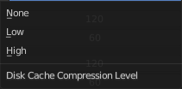
Disk Cache Compression
Use compression or not for the disk cache. Compression saves space but needs calculation.

Texture Time Out
Time since last access of a GL texture in seconds, after which it is freed. Set to 0 to keep textures allocated. Minimum: 0, Maximum: 3600.

Garbage Collection Rate
Number of seconds between each run of the GL texture garbage collector. Minimum: 0, Maximum: 3600.

VBO Time Out
Time since last access of a GL Vertex buffer object, in short VBO, in seconds after which it is freed. Set to 0 to keep VBO allocated.

Garbage Collection Rate
Number of seconds between each run of the GL vertex buffer garbage collector. Minimum: 0, Maximum: 3600.

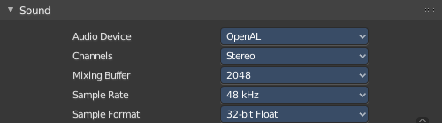
Sound

Audio Device
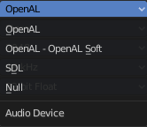
Set the audio device.

OpenAL
Provides buffered sound rendering with 3D/spatial support.

OpenAL - OpenAL Soft
Provides buffered sound rendering with 3D/spatial support.

SDL
Uses Simple Direct Media Layer API from libsdl.org to render sounds directly to the sound device output.

Null
No Audio support. No audio output, but audio strips can be loaded normally.

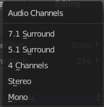
Channels
Set the audio channel count. Available options are: Mono, Stereo, 4 Channels , 5.1 Surround , 7.1 Surround

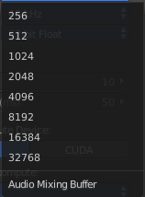
Mixing Buffer
Set the number of samples used by the audio mixing buffer. Available options are: 512 , 1024 , 2048, 4096 , 8192, 16384, and 32768

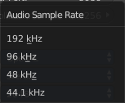
Sample Rate
Set the audio sample rate. Available options are: 44.1 Khz, 48 Khs, 96 Khz and 192Khz

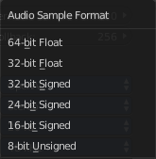
Sample Format
Set the audio sample format. Available options are: 32 bit float, 8 bit Unsigned, 16 Bits Signed, 24 Bits Signed, 32 Bits Signed, 32 Bits Float, and 64 Bits Float.

Save & Load

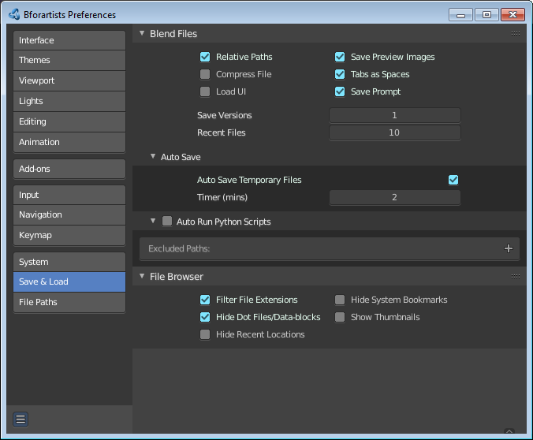
Blend Files
Blend file related settings. What happens at load, what happens at save ...

Relative Paths
By default, external files use a relative path.

Compress File
Compress blend-file when saving.
The option to Compress files will compact your files whenever Blender is saving them. Dense meshes, large packed textures or lots of elements in your scene will result in a large blend being created.
This option may slow down Blender when you quit, or under normal operation when Blender is saving your backup files. Using this option traces processor time for file-size.

Load UI
In Bforartists you can load the scene in the screen layout in which you have saved it. Default is off.
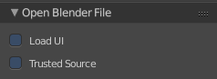
This can also be changed individually when loading a file from the Open blend-file panel of the File Browser.

Save Preview Images
When this option is off, previews of images and materials in the File Browser are created on demand. With this option on it will save these preview images into your blend-file. This will increase the size of your blend file by the size of the thumbnails.

Tabs as Spaces
For text files, automatically convert tabs into spaces when loading a blend file that contains a text file. Correct indentation is relevant for python scripts.

Save Prompt
Ask for confirmation when quitting with unsaved changes.

Save Versions
Number of versions created for the same file (for backup).
This option tells Bforartists to keep the indicated number of saved versions of your file in your current working directory when you manually save a file. These files will have the extension: .blend1, .blend2, etc., with the number increasing to the number of versions you specify. Older files will be named with a higher number. e.g. With the default setting of 2, you will have three versions of your file: *.blend (your last save), *.blend1 (your second last save) and *.blend2 (your third last save).

Recent Files
The number of recent files to display in the Recent panel.

Auto Save

Auto Save Temporary File
Enable Auto Save. Auto save creates a temporary file.
Checking this box tells Blender to automatically save a backup copy of your work-in-progress to the Temp directory (refer to the File tab in the Preferences for its location).
The Auto Saved files are named using a random number and have a blend extension.

Timer
Adjust the number of minutes between each Auto Save. The minimum is 1, and the Maximum is 60 (Save at every one hour).

Auto Run Python Scripts
Run the python scripts at loading a blend file that includes these scripts.

Excluded paths
Define file paths where loaded blend files should not run the included scripts even when auto run python scripts is ticked.

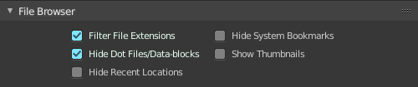
File Browser
File browser related settings.

Filter File Extensions
By activating this, the file dialog in the File Browser will only show appropriate files in the Load dialog. Blend files for example.
The selection of file types can also be changed in the header of the file dialog.

Hide Dot File/Data-blocks
On non Windows systems like Linux and Mac OS X files are hidden by a dot in front of the file name. Here you can make them visible in the file browser if you want. Note that this feature does not work with Windows.

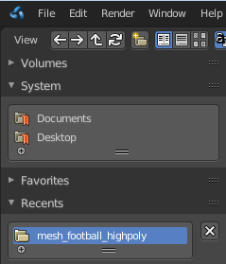
Hide Recent Locations
Hides the Recent panel of the File Browser which displays recently accessed folders.

Hide System Bookmarks
Hides the System Bookmarks panel of the File Browser which displays the system bookmarks.

Show Thumbnails
Displays a thumbnail of images and movies when using the File Browser.

File Paths
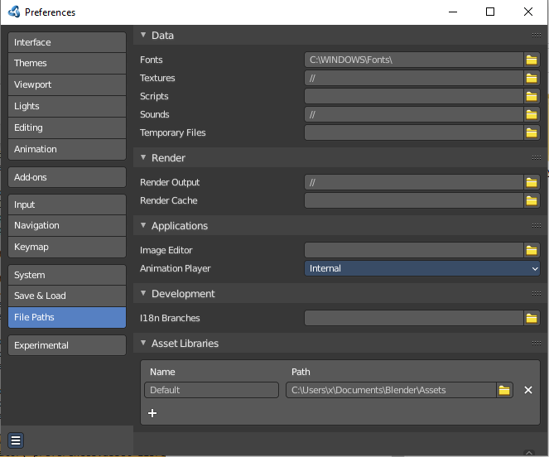
Contains everything file path related.

Data

Fonts
Default location when searching for font files.

Textures
Default location when searching for image textures.

Scripts
An additional location to search for Python scripts.
By default Bforartists looks in several directories (OS dependent) for scripts. Here you can add another directory to check for scripts. This can be used to store certain scripts/templates/presets independently of the currently used Blender Version.
Inside the specified folder specific folders have to be created to tell Bforartists what to look for where. This folder structure has to mirror the structure of the scripts folder found in the installation directory of :
- scripts
- add-ons
- modules
- presets
- camera
- cloth
- interface_theme
- operator
- render
- ...
- startup
- templates
Not all of the folders have to be present.
Python scripts (including driver expressions) are not executed by default for security reasons.

Sounds
Default location when searching for sound files.

Temporary Files
The location where temporary files are stored.

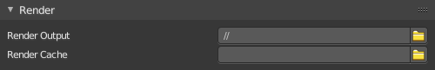
Render

Render Output
Where rendered images/videos are saved.

Render Cache
The location where cached render images are stored.

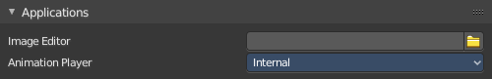
Applications

Image Editor
The path to an external image editing software to use for image editing. Photoshop, Gimp, etc.

Animation Player
By default Bforartists uses the internal player to play back animations. Choose an external program to use for playback of rendered animations. There are also some presets available.

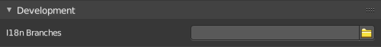
Development

I18n Branches
The path to the /branches directory in your local repository translation copy. This allows translating the UI. See interface tab, the translation panel.

Asset Libraries
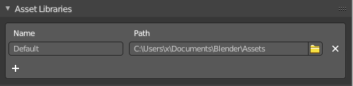
The default paths for custom asset libraries. The functionality should be self explaining.

To change the path simply type in a path, or use the path picker at the end.
To add a new path to an asset library click at the + button below the list.
To remove a path click at the X button at the end.

Experimental

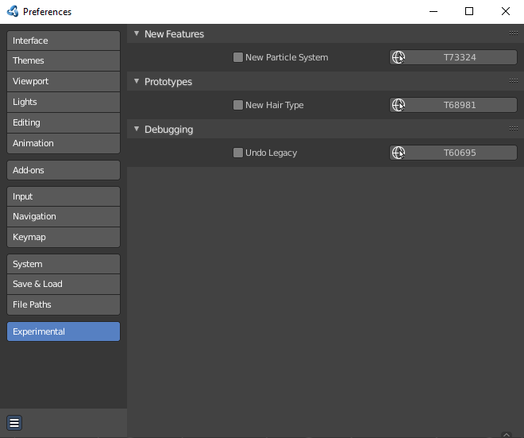
Here you may find some experimental settings from the Blender development. We will not cover them here. They change very quick. Use at own risk!

